Abstract

Cab Services application specializing in Hiring cabs to customers. It is an online system through which customers can view available cabs; register the cabs, view profile and book cabs. Cab Booking services is a web based platform that allows your customers to book their taxi's and executive taxis all online from the comfort of their own home or office. The platform should offer an administration interface where the taxi company can manage the content, and access all bookings and customer information.

 Cab Service acts like a bridge between the cab operators & the customers/ users/ people who book a cab. This is the online cab booking service provided to customers. This bridges together the registration travel agencies/ cab operators/ cab owners & the customers.This provides service with well-conditioned new vehciles, with experience drivers for a happy journey of the customers. This project intends to introduce more user friendly in the various activities such as record updating, maintenance, and searching.

# 1. INTRODUCTION

In today’s era, everyone wants convenience and comfort in daily life activities but everywhis not possible. Travelling is also a major part of day-to-day activities and in same case alsopeople wants same comfort assistance in whole journey. Taking this statement, we came to the solution that will provide the comfort as well as secuourney provided. OCBS is an android application which lets you book cabs for the intercity and intra-city travpurpose using your Smartphone and provides you the best service that will make your journmore luxurious. The objective of OCBS project is to automate vehicle rental and reservation. So customers dneed to call & spend unnecessary time in order to reserve preferred vehicle. They can go onand reserve any preferred kind of Cab they want , which is available at that time.

## Objective

This project deals with the ‘Cab Booking Service’. The system is used for daily activities such as booking,cancelled, delivery, status check, and managing customer. It is very difficult to do this process manually. Hence it is recommended to computerize the process by developing the relative software as the world is turning into information and technology; computerization becomes necessity in all walks of life.

## Existing System

Existing Online Cab Booking project system requires lots of physical and mental efforts as cabs are booked manually on call.  
 Many chances of human errors such as wrong entry of journey date, time and location are recorded manually in a register by an employee thereby increasing chances of mis registration.

No clear communication among drivers, passengers and the office leading to a denial of service.  
 Punctuality is not maintained and faster accessibility of cabs is not possible due to traffic and miscommunication issues.

Level of sharing of information is weak.

Customers suffer a lot in terms of comfort and safety.

Maintaining and assigning responsibilities to the cab drivers by the service providers becomes difficult in the long run.

## Proposed System

The proposed Online Cab Booking project system ensures that the users can book the cab as per their requirements by logging on to the website.

It allows users to book their cabs online, manage their bookings and cancel their bookings at any point of time.

The users will get notified about the driver and his mobile no. so as to communicate with him.  
Regular updates are provided to the customer so that they are aware of their bookings, driver details, and booking status.

The user can also drop in their suggestions or queries in the feedback form.

**ADVANTAGES**

It enhances business processes since it makes use of internet technology to increase their profits.

The software acts as a 24/7 office due to its all-time availability.

It increases the efficiency of the system in offering quality services to its customers.

It’s user-friendly as they can book cabs from the comfort of their homes or offices.

It’s highly secure as it requires only a logged in person to book the cab which prevents misuse of their details by intruders.

# 2. SYSTEM ANALYSIS AND DESIGN

System analysis is the performance management and documentation of activities related to the life cycle phases of any software namely:

* + - * The Study Phase
      * The Design Phase
      * The Development Phase
      * The Implementation Phase
      * The Testing Phase

Software Analysis starts with a preliminary analysis and later switches on to a detailed one. During the preliminary analysis the Analyst takes a quick look at what is needed and whether the cost benefits. Detailed analysis studies in depth all the cornered factors, which builds and strengthens the software.

## SRS

The introduction of the Software Requirements Specification (SRS) provides an overview of the entire SRS with purpose, scope, definitions, acronyms, abbreviations, references and overview of the SRS. The aim of this document is to gather and analyze and give an in-depth insight of the complete requirements of our project by defining the requirements in detail. Nevertheless, it also concentrates on the capabilities required to run out project on different high-level software features.

### Functional Requirements

The system after careful analysis has been identified to present itself with the following modules:

* + - * Cab Information Module
      * Search Cab Module
      * Booking Cab Module
      * Feedback Module
      * Report Module

**Cab Information**

In this module an authorized administrator upload all cab details into the server. The admin upload a cab no, cab registration no, driver name, contact details, location, photo, license no and cab available details into the server. The admin have the privileges to modify or delete the cab information. The admin control the entire system.

**Search Cab**

In this module the user able to access the cab details.To access this system the user must be register and get their own login credential.Using this information the user access the system. They able to view the cab details such as cab availability, charges per kilometer, facility in the cab etc. They able to search cab based on their needs.

**Booking**

In this module a user able to book the cab. In this cab booking module source and destination of the travel, booking date, booking time and much information is captured from the user. if the cab is available the booking process is complete. Booking status and driver information also maintained in the server.

**Feedback**

In this module a user able to enroll their travel experience and feedback about the cab services. The remarks about the driver also mentioned in this feedback module. This information is maintained confidentially and securely.

**Report**

In this module the admin able to view the report about the cab services. In this report they admin able to view how many cabs are booked for a particular date, how many cabs successfully completed.

### Hardware Requirements

**HARDWARE SPECIFICATION**

* + - * CPU Type : Intel(R) Pentium(R) CPU 2020M
      * Clock Speed : 2.40 GHz
      * RAM : 2GB
      * Keyboard : Multimedia
      * Mouse : OPTICAL Mouse
      * Hard Disk : 500GB

### Software Requirements

* + - * Operating System : Windows XP
      * WAMP : Web Application Server
      * PHP : Server Side Scripting Language
      * MYSQL : Database
      * HTML : Hyper Text Mark-up Language

## System Analysis and Design

System design is the second step in the system life cycle, in which overall design of the system is achieved. The functionalities of the system is designed and studied in this phase. The first step is designing of program specification. This determines the various data inputs to the system, data flow and the format in which output is to be obtained.

Design phase is a transmission phase because it is a transition from user oriented document to computer data. The activity in the design phase is the allocation of functions to manual operations, equipment and computer programs. Flow charts are prepared in the study time and is decomposed until all functions in the system perform evidently.

Design is a multi-step process that focuses on data structures, software architecture, procedural details (algorithms etc.) and links between the modules. The design process goes through logical and physical stages. In logical design reviews are made linking existing system and specification gathered. The physical plan specifies any hardware and software requirement, which satisfies the local design.

Modularization of task is made in this phase. The success of any integrated system depends on the planning of each and every fundamental module. Usually a project is revised in step by step sequence. Inter-phase management of such module is also important. Software design methodology changes continually as new methods, better analysis and broader understanding evolve.

Various techniques for software design do exit with the availability of criteria for design quality. Software design leads three technical activities-design, code and test.

Each activity transforms information, which validates the software. The design system converts theoretical solution introduced by the feasibility study into a logical reality.

## System Design

* + 1. **ER Diagrams**

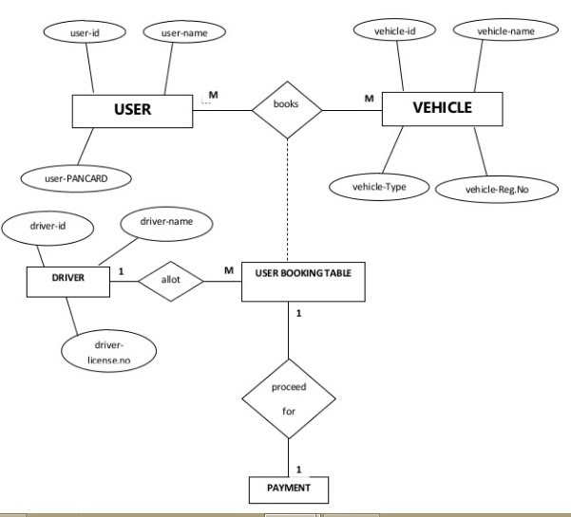

### Analysis Diagrams

* + 1. **Use Case Diagram**

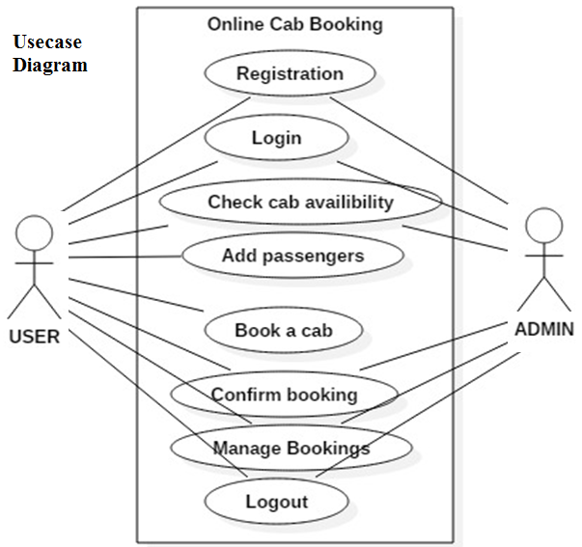

* 1. **Logic Design**
     1. **Sequence Diagram for Login**

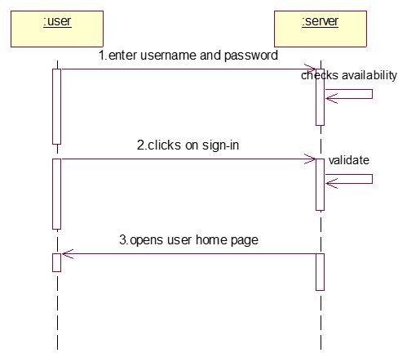

* + 1. **Sequence Diagram for Cabbooking**

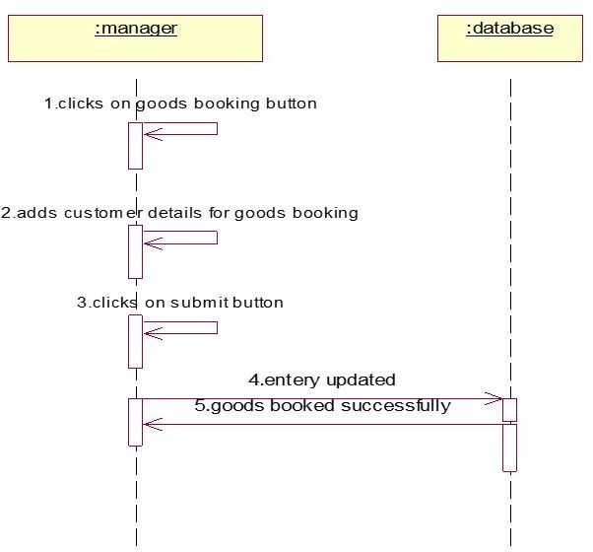

* + 1. **Sequence Diagram for New Branch Request**

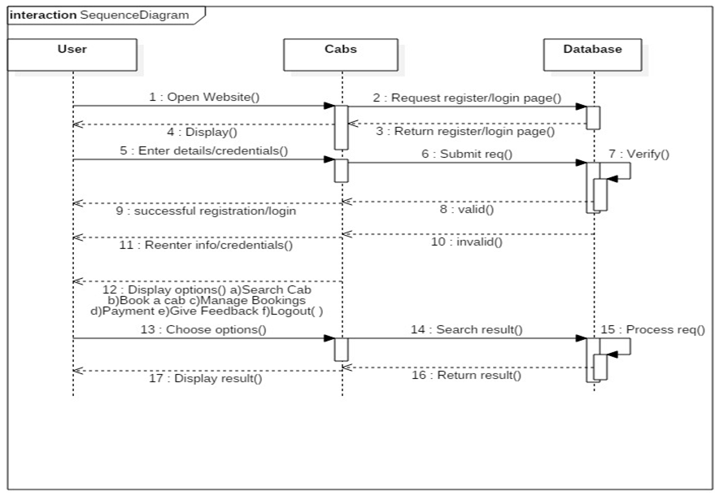

* + 1. **Activity Diagram**

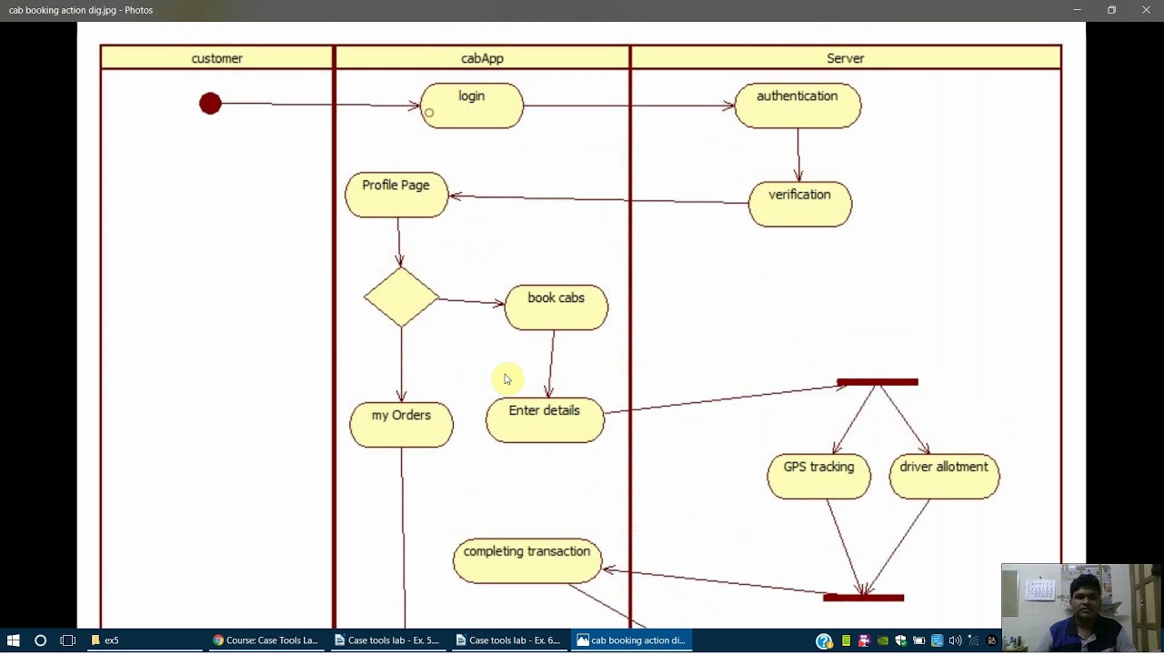

* + 1. **Class Diagram**

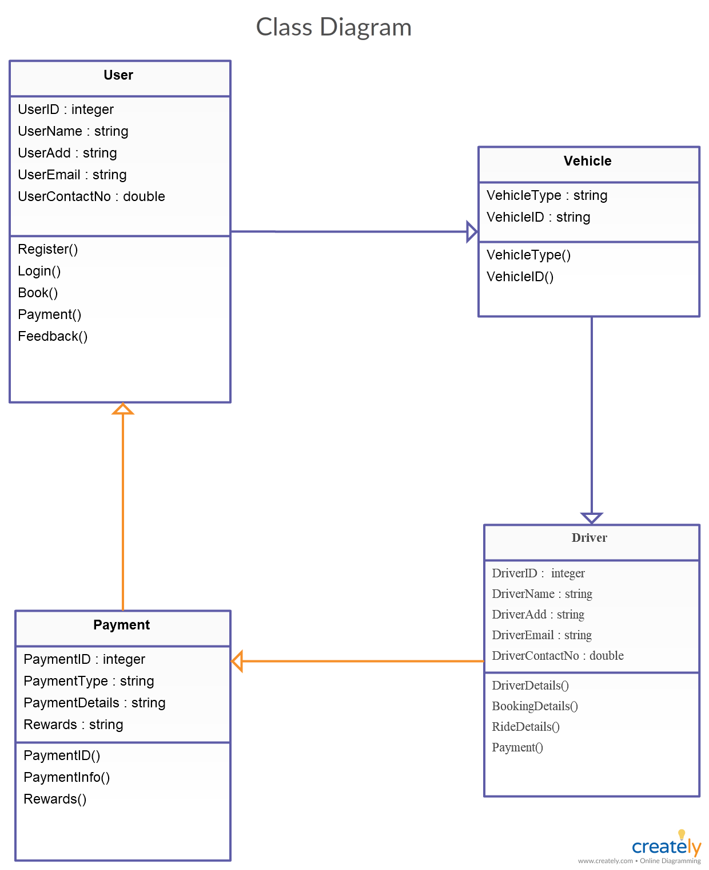

1. **IMPLMENTATION**
   1. **Module Screens**

# TESTING

## Introduction to Testing

Testing is a process, which reveals errors in the program. It is the major quality measure employed during software development. During software development. During testing, the program is executed with a set of test cases and the output of the program for the test cases is evaluated to determine if the program is performing as it is expected to perform.

## Sample Test Cases

### 4.2.1 +Ve Test Cases

|  |  |  |  |  |
| --- | --- | --- | --- | --- |
| **S No** | **Test case Description** | **Actual value** | **Expected value** | **Result** |
| 1 | Login  (Admin, Customer, ) | Entering into their respective home pages | Respective Home Pages with Options | True |
| 2 | Entering data in to database | Asks for the Valid Data Enter | Data stored successfully | True |
| 3 | Generating Reports | Admin can generate the reports | Generated all reports successfully | True |
| 4 | Accessing the stored data | As per the permissions Admin, can access the stored data | Shows the stored data according to permissions | True |

**4**

### Testing Screen shat to test the system with valid username and password

If we provide the valid user id and password to test the system. It accept and go to the home page of the user.

### 4.2.2 -Ve Test Cases

|  |  |  |  |  |
| --- | --- | --- | --- | --- |
| **S No** | **Test case Description** | **Actual value** | **Expected value** | **Result** |
| 1 | Login  (Admin, Customer) | Credentials should be same as saved in DataBase | With wrong credentials no member can be logged in | False |
| 2 | Entering data in to database | Only valid format data can store. | Other than that formats data can’t be stored | False |
|  |  |  |  |  |
| 3 | Accessing the stored data | As per the permissions Admin can access the stored data | If Admin or manager try to access the data with out access permission. It`s not allow. | False |

**5**

# CONCLUSION

## Conclusion

The “Cab booking application ” is successfully designed and

developed to fulfilling the necessary requirements, as identified in the requirements analysis phase, such as the system is very much user friendly, form level validation and field level validation are performing very efficiently.

The new computerized system was found to be much faster and reliable

And user friendly then the existing system, the system has been designed and developed step by step and tested successfully. It eliminates the human error that are likely to creep in the kind of working in which a bulk quantity of data and calculations as to be processed.

The system results in quick retrieval of information that is very vital

for the progress any organization. Cost is minimized in case of stationary. Burden of manual work is reduced as whenever transaction takes place, there is a no need to record it in many places manually.

The objective of this project was to build a program for

Maintaining the details of all the Customer, Trainer and inventory .The system developed is able to meet all the basic requirements. The management of the records (both Customer and Trainer) will be also benefited by the proposed system, as it will automate the whole procedure, which will reduce the workload. The security of the system is also one of the prime concerns.

# References

Sites:

www.google.com

www.fristflight.com

www.bluedart.com

www.microsoft.com

Books:

1. PHP Manual

2. JavaScript Manual

3. Mastering SQL Server 2000 by -Gunderloy, Jorden BPB Publications

4. Beginning SQL Server 2000 by -Thereon Willis wrox publications

5. SOFTWARE ENGINEERING -ROGER S.PRESSMEN, T. Mc. GH.

**Journals**

1. Chauhan A., Singh S., Jain A. and Kumar R. (2010)  
**“High-Tech Courier Services as an E-Courier services in India Prospective”**

2. Azeta, A. A., Ogunlana A. O. and Ezeh C. O., (2010)  
**“Design and Implementation of a Mobile Express Delivery System”**

Appendix

A1 **About PHP and MySQL**

PHP is the Web development language.

PHP stands for PHP: Hypertext Pre-processors.

 PHP is a Server-side scripting language, which can be embedded in

HTML or used as a standalone binary.

Rasmus Lerdorf – a software engineer, Apache team member is the

creator and original driving force behind PHP.

Strictly speaking, PHP has little to do with layout, events, on the fly

DOM manipulation, or really anything about what a Web page looks and

sounds like. In fact, most of what PHP does is invisible to the end user.

Someone looking at a PHP page will not necessarily be able to tell that it was

not written purely in HTML, because the result of PHP is HTML.

The PHP pre-processor has two modes of operation, copy mode and

interpret mode. It takes a PHP document file as input and produces an XHTML

document file.

PHP is usually purely interpreted. The syntax and semantics of PHP are closely

related to the syntax of JavaScript and Perl. It uses dynamic typing. PHP has an

extensive library of functions, making it a flexible and powerful tool for server-

side software development.

MySQL (pronounced My Ess Q El) is an open source. MySQL is a free,

highly efficient, widely used database system that implements SQL. There are a

plethora of tools, both in MySQL itself and available from third parties, to make

this job even easier. MySQL isn’t a database until you give it some structure

and form.

PHP is an open-source language, and PHP.net is its control centre, with

extensive reference material about the language and tips sent in by users across

the globe. PHP.net has exceptional, deep information about the language, but it

can be a little cryptic for the newcomer.

Speed: It is relative fast since it uses much system resource.

Easy to use: It uses C like syntax, so for those who are familiar with C, it&#39;s very

easy for them to pick up and it is very easy to create website scripts.

Stable: Since it is maintained by many developers, so when bugs are found, it

can be quickly fixed.

Powerful library support: You can easily find functional modules you need such

as PDF, Graph etc.

Built-in database connection modules: You can connect to database easily using

PHP, since many websites are data/content driven, so we will use database

frequently, this will largely reduce the development time of web apps.

Can be run on many platforms, including Windows, Linux and Mac, it&#39;s easy for

users to find hosting service providers.

**About Wamp Server**

Stands for &quot;Windows, Apache, MySQL, and PHP.&quot; WAMP is a variation

of LAMP for Windows systems and is often installed as a software bundle

(Apache, MySQL, and PHP). It is often used for web development and internal

testing, but may also be used to serve live websites.

The most important part of the WAMP package is Apache (or &quot;Apache HTTP

Server&quot;) which is used run the web server within Windows. By running a local

Apache web server on a Windows machine, a web developer can

test webpages in a web browser without publishing them live on the Internet.

WAMP also includes MySQL and PHP, which are two of the most common

technologies used for creating dynamic websites. MySQL is a high-speed

database, while PHP is a scripting language that can be used to access data from

the database. By installing these two components locally, a developer can build

and test a dynamic website before publishing it to a public web server.

## Web Application:

It has also added user as well as system based web applications enhancement to add support for deployment across the variety of environments. It also tries to manage session as well as applications across the network.

Tomcat is building additional components. A number of additional components may be used with Apache Tomcat. These components may be built by users should they need them or they can be downloaded from one of the mirrors.

## HTML

Hypertext Markup Language (HTML), the languages of the World Wide Web (WWW), allows users to produces web pages that included text, graphics and pointer to other web pages (Hyperlinks).

HTML is not a programming language but it is an application of ISO Standard 8879, SGML (Standard Generalized Markup Language), but Specialized to hypertext and adapted to the Web. The idea behind Hypertext one point to another point. We can navigate through the information based on out interest and preference. A markup language is simply a series of items enclosed within the elements should be displayed.

Hyperlinks are underlined or emphasized works that load to other documents or some portions of the same document. Html can be used to display any type of document on the host computer, which can be geographically at a different location. It is a versatile language and can be used on any platform or desktop. HTML provides tags (special codes) to make the document look attractive.

HTML provides are not case-sensitive. Using graphics, fonts, different sizes, color, etc... Can enhance the presentation of the document. Anything that is not a tag is part of the document itself.

## Basic Html Tags

<!-- --> Specific Comments.

<A>………</A> Creates Hypertext links.

<B>………</B> Creates hypertext links.

<Big>……..</Big> Formats text in large-font

<Body>…….</Body> contains all tags and text in the Html- document

<Center>……</Center> Creates Text

<DD>………..</DD> Definition of a term.

<TABLE>……</TABLE> creates table

<Td>………..</Td> indicates table data in a table.

<Tr>………..</Tr> designates a table row

<Th>……….</Th> creates a heading in a table.

## Advantages

* + A HTML document is small and hence easy to send over the net.It is small because it does not include formatted information.
  + HTML is platform independent
  + HTML tags are not case-sensitive.

## JAVA Script

JavaScript is a compact, object-based scripting language for developing client and server internet applications. Netscape Navigator 2.0 interprets JavaScript statements embedded directly in an HTML page. And Livewire enables you to create server-based applications similar to common gateway interface (cgi) programs.

In a client application for Navigator, JavaScript statements embedded in an HTML Page can recognize and respond to user events such as mouse clicks form Input, and page navigation.

For example, you can write a JavaScript function to verify that users enter valid information into a form requesting a telephone number or zip code. Without any network transmission, an Html page with embedded Java Script can interpret the entered text and alert the user with a message dialog if the input is invalid or you can use JavaScript to perform an action (such as play an audio file, execute an applet, or communicate with a plug-in) in response to the user opening or exiting a page.